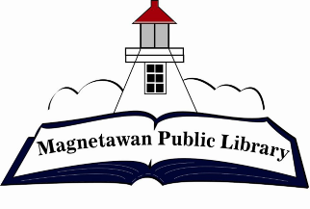
Magnetawan Public Library
Agenda
Wednesday, April 15, 2026
5:15pm

- Call to order

- Approval of agenda

- Approval of last meeting minutes

- Declaration of Conflict of Interest

- New Business

- Separate bank account for raffles & 50/50 draws

- Business Arising

- Chair Report – N/A

- Librarian Report – Available at the meeting

- Unfinished/Ongoing Business

- Signing authority at Kawartha Credit Union

- Question period for public

- CLOSED SESSION as per Labour relations or employee negotiations Sec.16 (4)(d)

- Discussion of resumes from applicants

- Next meeting will be held at 5:15pm on Wednesday, May 20, 2026

