Magnetawan Public Library
LIBRARY BOARD MEETING MINUTES

DATE AND TIME | Wednesday, March 25, 2026 5:15pm
LOCATION | Magnetawan Public Library
ATTENDEES | Mary Bishop, Elinor Raaflaub, Lorinda Makoviczki, Julie Ferris, Michael Fleming, Jon Hind
REGRETS
CALL TO ORDER | 5:23pm

DECLARATION OF CONFLICT OF INTEREST
2026-02

APPROVAL OF AGENDA
2026-03 Moved: Julie Ferris
Carried Seconded: Jon Hind
Be it resolved that the Agenda for this meeting be approved.

APPROVAL OF LAST MEETING MINUTES
2026-04 Moved: Mary Bishop
Carried Seconded: Julie Ferris
Be it resolved that the last meeting minutes be approved.

2026-05 - NEW BUSINESS

2026-06 - BUSINESS ARISING

2026-07 - CHAIR REPORT

2026-08 – LIBRARIAN REPORT

2026-09 - UNFINISHED/ONGOING BUSINESS
- Campfire Poet & Lions Club collaboration
- Doors will open at 6pm
- Lions will give a donation for the late night snack
- Legion will start at 7pm, Lorinda will call to book
- Band will start at 8pm
- Lorinda will make up tickets to sell before hand - $35 early bird special - $40 at the door
- We will have a stamp, so that people can come and go.

- Budget was by the Municipality of Magnetawan

- Elinor and Mary will go to Kawartha Credit Union as soon as possible to be added to the signing authority

- Lorinda will look into getting a Bear Chair or something similar to raffle off this summer – can spend up to $200 on the item

2026-10 - QUESTION PERIOD FOR THE GENERAL PUBLIC
- Suggestion that the used books price can be increased

2026-11 - CLOSED SESSION

2026-12 - Next meeting will be held at 5:15pm on Wednesday May 20, 2026 @ Magnetawan Public Library

ADJOURNMENT
2026-13 Moved: Julie Ferris
Carried Seconded: Elinor Raaflaub
Be it resolved that the meeting adjourned at 6:01pm

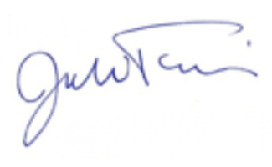
Julie Ferris Library Board Chair

