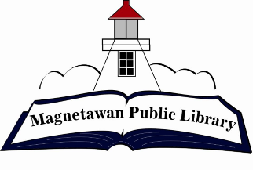
Magnetawan Public Library
Agenda
Wednesday, January 14, 2026
5:15pm

- Call to order

- Approval of agenda

- Approval of last meeting minutes

- Declaration of Conflict of Interest

- New Business

- Library budget for 2026

- Business Arising

- Chair Report – N/A

- Librarian Report – Available at the meeting

- Unfinished/Ongoing Business

- Question period for public

- Next meeting will be held at 5:15pm on Wednesday February 11, 2026

