Magnetawan Public Library

LIBRARY BOARD MEETING MINUTES

|  |  |
| --- | --- |
| DATE AND TIME | Tuesday May 28 2024, 7:OOpm |
| LOCATION | Magnetawan Public Library |
| ATTENDEES | Lorinda Makoviczki, Mary Bishop, Julie Ferris, Jon Hind, Elinor Raaflaub, Michael Fleming |
| REGRETS |  |
| CALL TO ORDER | 7:15pm |

# APPROVAL OF AGENDA

2024-02 Moved: Julie Ferris

Carried Seconded: Michael Fleming

Be it resolved that the Agenda for this meeting be approved.

# APPROVAL OF LAST MEETING MINUTES 2024-03 Moved: Mary Bishop

Carried Seconded: Michael Fleming

Be it resolved that the last meeting minutes be approved.

DECLARATION OF CONFLICT OF INTEREST

2024-04

2024-05 - NEW BUSINESS

2024-06 - BUSINESS ARISING

2024-07 - CHAIR REPORT  N/A

# 2024-08 - LIBRARIAN REPORT

 See attached petty cash information

# 2024-09 - FUNDRAISING COMMITTEE We will be selling freezies, and T-shirts at our book sales

 We will be having a book sale every Saturday until Thanksgiving

1

# 2024-10 - UNFINISHED/ONGOING BUSINESS

* We have 6 graduates from MCS, Lorinda will purchase $25 Walmart gift cards to give out
* Lorinda will be attending the grade 8 graduation, so Tuesday, June 25 the library will open at 11:30am

# 2024-11 - QUESTION PERIOD FOR THE GENERAL PUBLIC

2024-12 - CLOSED SESSION

 Labour relations or employee negotiations Sec.16(4)(d) Public Library Act

Next meeting will be held at 7:00 pm on June 26, 2024 @ Magnetawan Public Library

# ADJOURNMENT

2024-13 Moved: Lorinda Makoviczki

Carried Seconded: Mary Bishop

Be it resolved that the meeting adjourned at 8:12pm

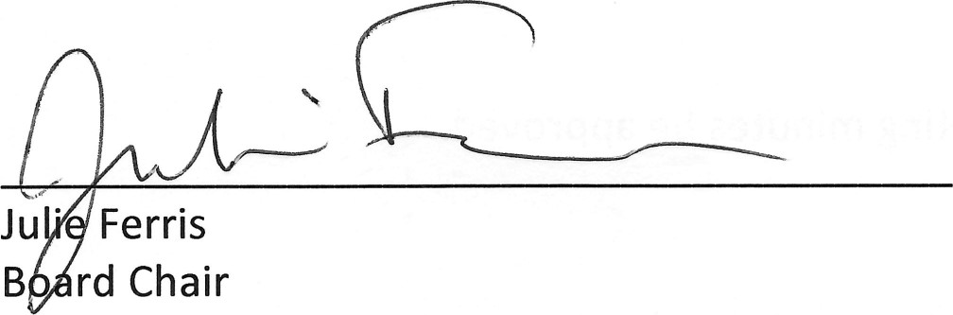

2