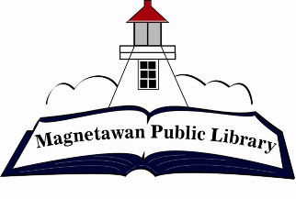
Magnetawan Public Library
Agenda
Tuesday, March 26, 2024

- Call to order

- Approval of agenda

- Approval of last meeting minutes

- Declaration of Conflict of Interest

- New Business – Summer student – honorarium

- Business Arising

- Chair Report – N/A

- Librarian Report –

- Fundraising Committee report – Decisions to be made on fundraising

- Unfinished/Ongoing Business

- Question period for public

- Closed session – Library employees

- Next meeting will be held at 7:00pm on Tuesday, April 30, 2024

- Adjournment

