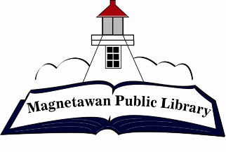
Magnetawan Public Library
Agenda
Tuesday, February 27, 2024

- Call to order

- Approval of agenda

- Approval of last meeting minutes

- Declaration of Conflict of Interest

- New Business

5.1 – Canada Post Grant
5.2 –

- Business Arising

- Chair Report – N/A

- Librarian Report –

- Fundraising Committee report

- Unfinished/Ongoing Business
10.1 – Budget for 2024
- AED machine supplies
- Municipality update

10.2 – Policy Completion

- Question period for public

- Closed session – N/A

- Next meeting will be held at 7:00pm on Tuesday, March 26, 2024

- Adjournment

