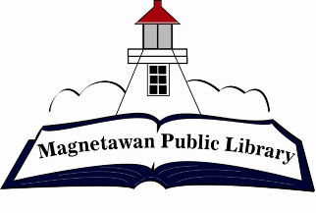
Magnetawan Public Library
Agenda
Tuesday November 28, 2023

- Call to order

- Approval of agenda

- Approval of last meeting minutes

- Declaration of Conflict of Interest

- New Business

5.1 – Appoint Acting Chair Sec 14(4) Public Libraries Act
5.2 – Appoint a member for signing authority

- Business Arising

- Chair Report – N/A

- Librarian Report – see attached

- Fundraising Committee report – see attached

- Unfinished/Ongoing Business
10.1 – Budget Report - October
10.2 – Policy Completion

- Question period for public

- Closed session

12.1 – Labour relations or employee negotiations
Sec 16 (4) (d) Public Library Act

- Next meeting will be held at 7:00pm on Tuesday, January 30, 2024

- Adjournment

